**Automation Demo:**

1.Is SW Testing a good career?

1. **Job security & high demand:**

* Software testing is among the most in-demand careers Where there is software, there is a tester!
* As long as software continues to be developed, there will always be a demand for skilled software testers.
* **Reports published in October 2022 predicted that India's software industry would nearly double in the next five years to $6.74 billion, with an annual growth rate of 12.25%.**
* This growth indicates that software testing is a relatively stable career choice.

1. **Many pathways and growth opportunities:**

* As the technology field is constantly growing, there will be an increasing need for professionals with software testing skills.
* Also, there are many pathways in the testing career.
* You can choose the path of your interest—**Manual testing, Automation testing, Performance testing, etc.**

1. **Full of fun and challenges:**

* A software tester who stops learning stops testing.
* As a software tester, you will never feel a moment of boredom.
* Each software product is structured differently and has different issues.
* You will have to use different approaches to test other software.
* Hence, you will always learn new things.

1. **Creative:**

* Software testing is an art.
* It requires you to identify defects by connecting hidden dots and thinking from different perspectives to dig out useful information.
* Isn’t that what makes software testing fun?

1. **Flexibility:**

* Many software testing positions offer flexible work hours, allowing you to work from home or choose a schedule that suits your lifestyle.

1. **Handsome remuneration:**

* Software testing is a highly demanding skill, and organizations are often willing to pay a competitive salary for the right individual.
* **Within five years of starting the career, the salary is expected to increase by 250–300%.** This factor makes the testing career more appealing!

1. **Impact on the end-user:**

* A company's most valuable assets, its customers, are at risk without proper software testing.
* Tested software applications are more reliable, user-friendly, and according to the requirements of the end-users.

**Who can pursue a software testing career?**

* **doesn’t require you to have a technical background** (a degree in engineering, math, or computer science).
* Any interested individual with dedication, a passion for technology, learning abilities, and a detail-oriented mind can become a software tester.
* A technical educational background can only be a little aid in grasping software testing concepts and methodologies more quickly than a non-technical person can.
* There is a set of technical and non-technical skills that an individual who wants to pursue software testing has to develop.

**Summing Up**

* Software testing is not just a job; it’s an adventure.
* It offers a wide scope and potential for future growth.
* Happy Learning!

**What is Software testing?**

* Software testing is a crucial part of building quality software; software development is incomplete without the testing process. In this process, a piece of software is evaluated or experimented with to uncover inevitable information. The information can be anything–a bug, a malfunction, a feature, a missing requirement, an improvement, etc.
* This valuable information is then transmitted to the stakeholders to help them improve the quality of the software.
* Hence, your ultimate goal as a software tester will be to identify any defects or issues in the software that could negatively affect the user experience. Whereas, a positive user experience can lead to increased sales and market share - that's how you add value to your organization!

**Types:**

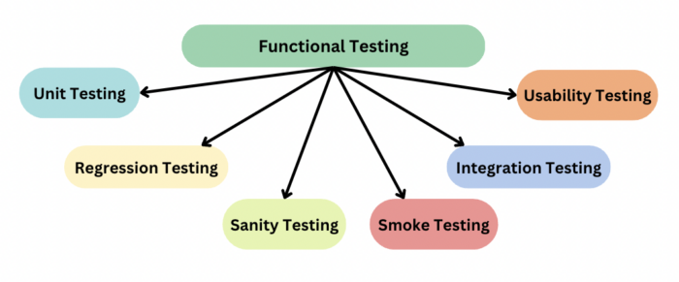

1.Smoke Testing.

2.Sanity Testing.

3.Functional Testing.

4.Non- Functional Testing.

5.Re-Testing.

6. Regression Testing.

7.UAT-User Acceptance Testing.

**Test Scenario**

* A **Test Scenario** is defined as any functionality that can be tested. It is also called *Test Condition* or *Test Possibility*.
* **Example of Test Scenario🡪**For an eCommerce Application, a few test scenarios would be

**Test Scenario 1:**Check the Search Functionality

**Test Scenario 2:**Check the Payments Functionality  
**Test Scenario 3:**Check the Login Functionality

**Test Case template:**

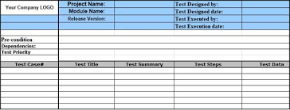

**Defect Life Cycle:**

**Bug/ Defect Report:**

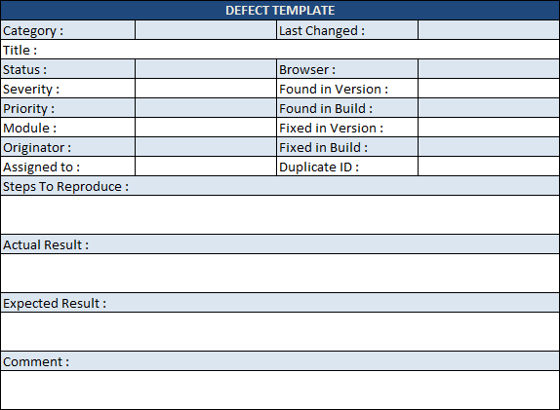

**API Testing:**

